**Year-To-Date (YTD) Message Review Instructions**

**All in One**

Updated on 2022-10-20 by Ying Shen

**Table of Contents**

**Version History** 3

**Instruction #1: Receive Confirmation that the YTD Message Transmission Has Finished** 4

**Instruction #2: YTD Message Review in MVPS and NNAD** 5

**Instruction #3: Results/Outputs Interpretation** 7

**Instruction #4: Instructions of YTD Data Load and Completeness Report** 9

**Instruction #5: Review Completeness Report** 11

# Version History

| Version # | Implemented By | Revision Date | Reason |
| --- | --- | --- | --- |
| 4.1 | Ying Shen | 10/20/2022 | Ying Shen updated the YTD bucket report SAS program by adding a new tab called MVPS Summary. This update is to add this change to the Results/Outputs Interpretation chapter. |
| 4.2 | Katherine Luce | 8/7/2023 | Included instructions on how to run a completeness report for YTD. Included information on CSV. |
| 5 | Katherine Luce | 8/16/2023 | Included instructions on exporting files to txt. Updated CSELS to OPHDST. |

## **Instruction #1: Receive Confirmation that the YTD Message Transmission Has Finished**

**Step1**: The Surveillance Office will receive communication from the Office of Public Health Data, Surveillance, and Technology (OPHDST) noting that the jurisdiction has finished their YTD message transmission. We expect OPHDST to let NCIRD know that all messages are received. NCIRD can double check in MVPS_PROD using the ***Confirm YTD Data Transmission Finished.SAS*** here.

** Before you run a SAS program, make sure you make a copy and add your initials. Do not change the original SAS program. Do not open and “save as,” but rather copy/paste the document and add your initials.***

**Step2**: If the primary and secondary running the case comparison report (from Instruction #2 and #3) receive different number of messages, run the ***Confirm YTD Data Transmission Finished.SAS*** here. Tell the SAS program the jurisdiction you’d like to check and run the SAS program.

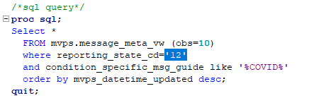

**Step3**: Check the msg_received_dttm and mvps_datetime_created in the Result Viewer.

(You may need to check this as many times as needed.)

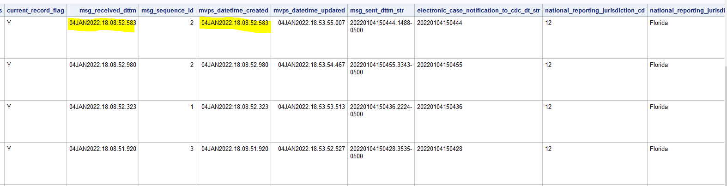

Once you are certain that the jurisdiction finished year-to-date message transmissions, resume Instruction #2.

## **Instruction #2: YTD Message Review in MVPS and NNAD**

**Step1**: Save the line list sent by the jurisdiction under the jurisdiction YTD folder here, for example, …\KY\COVID-19\YTD Messages. The jurisdiction line list is typically an excel spreadsheet which is from jurisdictions (through email), although the line list may also be a CSV file. Make sure the format of column “local record ID” is character.

If the line list is a text file (.txt), or over one million rows, save the file as a CSV (.csv). Although the file will not populate all rows if opened, all rows are in the CSV file.

**Step2**: Open ***YTD Message Review MVPS and NNAD.sas*** here and update the following info. Make sure the line list spreadsheet is where the “%let lnlist=xxx.xlsx” indicates.

** Before you run a SAS program, make sure you make a copy and add your initials. Do not change the original SAS program. Do not open and “save as,” but rather copy/paste the document and add your initials.***

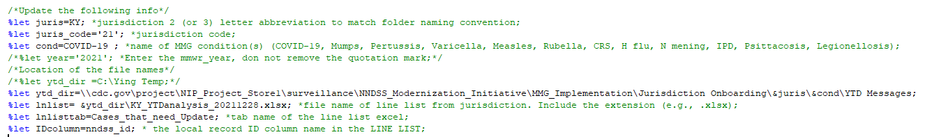

If the file is a CSV file, update the file name of the line list to .csv.

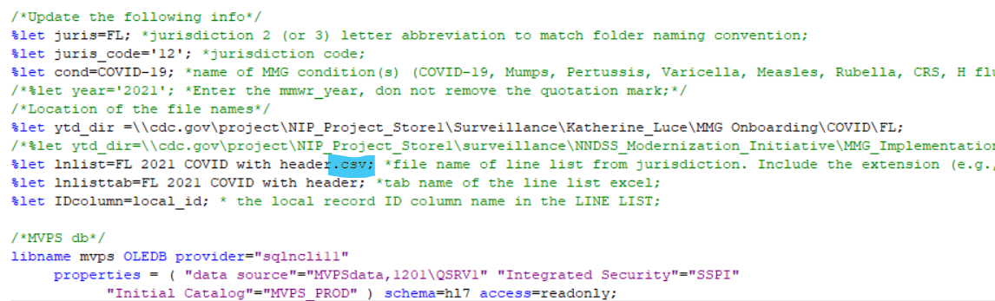

Comment out /* Import line list (excel) into sas */ and uncomment the section /* Import line list (CSV) into sas */.

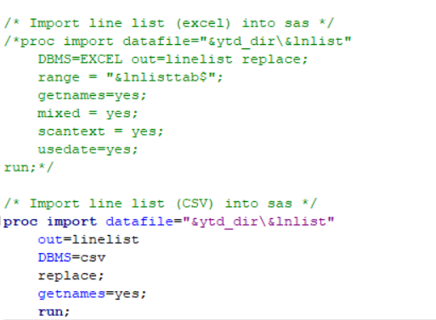

Review the outputted two Excel files:

***Cases Check in MVPS run on &sysdate9..xlsx***.

***Cases Check in NNAD run on &sysdate9..xlsx***.

If there is any issue in ***Cases Check in MVPS run on &sysdate9..xlsx***, let OPHDST and jurisdictions know. If ***Cases Check in MVPS run on &sysdate9..xlsx*** and ***Cases Check in NNAD run on &sysdate9..xlsx*** do not match, let NNAD Team know.

## **Instruction #3: Results/Outputs Interpretation**

1. **Cases Check in MVPS run on &sysdate9..xlsx**

There are five tabs/categories in this output. Each case should only belong to one category.

* Tab “***MVPS Summary***” (added in September 2022) provides a complete summary of all cases. Additionally, this tab provides a summary of which cases were received as GenV2 messages and which cases were not received by in MVPS for “***Cases Not Received as COVID***”.

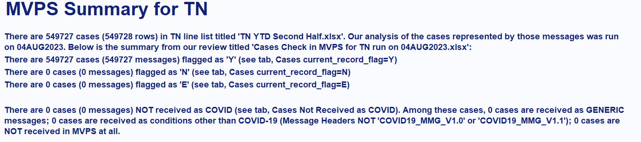

* Tab “***Cases current_record_flag=Y***”: successfully received as COVID message and flagged correctly. Eventually, all messages should be in this category.
* Tab “***Cases current_record_flag=N***”: successfully received as COVID message BUT flagged incorrectly. If there are any populated, you should let OPHDST investigate. MVPS may need to revise, or jurisdictions may need to re-submit.
* Tab “***Cases current_record_flag=E***”: received as COVID message BUT errored. If there are any populated, you should let OPHDST investigate.

Tab “***Cases Not Received as COVID***”: NOT received as COVID messages. If there are any populated, you should let OPHDST know so that OPHDST can ask jurisdictions to re-submit.

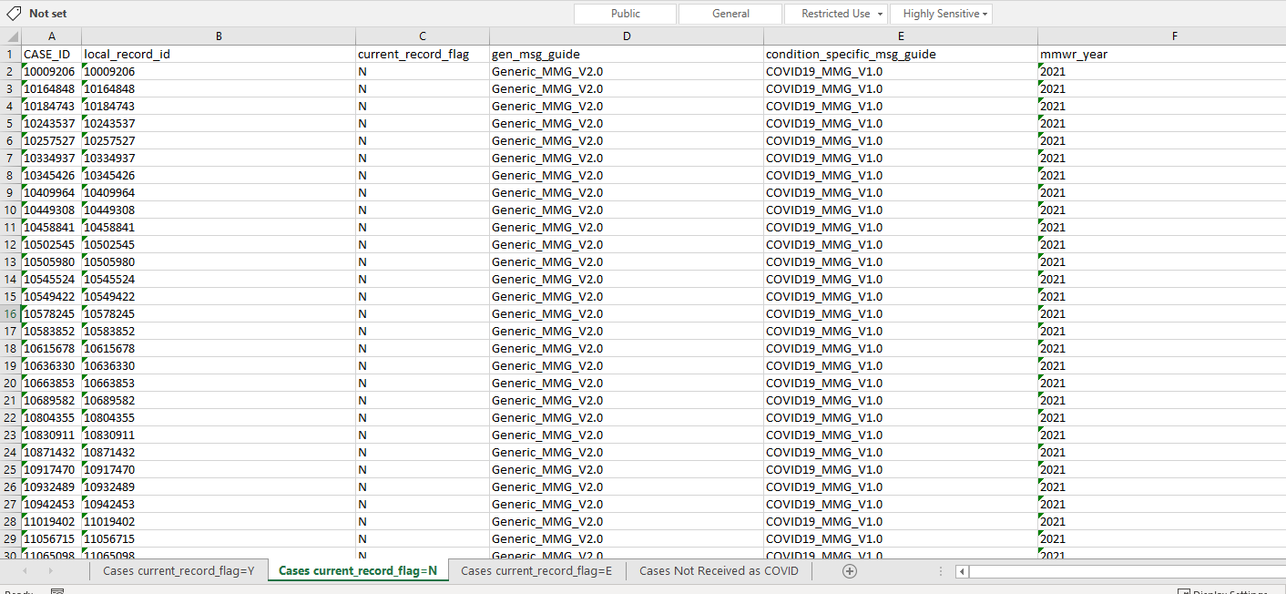

1. **Cases Check in NNAD run on &sysdate9..xlsx**

There are three tabs/buckets in this output. Each case should only belong to one bucket.

* Tab “***Cases_NNAD_Only***”: not in COVID line list but loaded as “COVID” message in NNAD. This is for NNAD team’s information, but no action is needed at this moment.
* Tab “***Cases_Line List_Only***”: in COVID line list but not in NNAD as “COVID” message.
* Tab “***Both_NNAD_Line_List***”: in COVID line list and successfully loaded into NNAD. All cases are expected to be in this bucket eventually.
* The sum of “***Cases_Line List_Only***” and “***Both_NNAD_Line_List***” should be equal to the sum of “***Cases current_record_flag=”Y***”, “***Cases current_record_flag=”N***”, “***Cases current_record_flag=”E***” and “***Cases Not Received as COVID***” in **Cases Check in MVPS run on &sysdate9..xlsx.** If not, let the NNAD team know.
* The number of “Both_NNAD_Line_list” should be equal to the number of “Cases current_record_flag=”Y”. If not, let the NNAD team know.

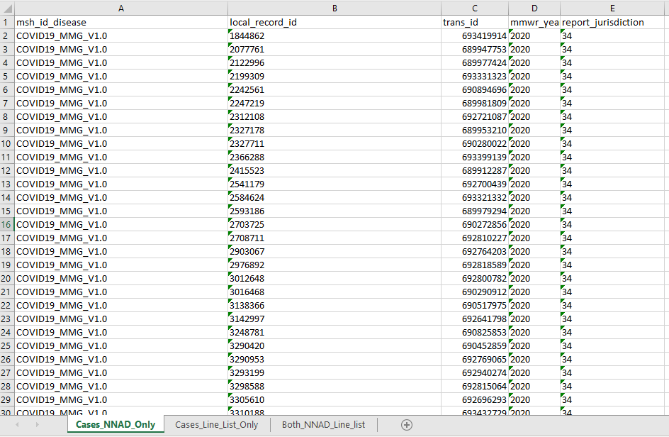

**Done! Have fun exploring.**

## **Instruction #4: Instructions of YTD Data Load and Completeness Report**

Once the Surveillance Office has received an email from OPHDST asking for a YTD completeness report, begin the following steps.

**Step0**: Open the SAS output titled “**Cases Check in NNAD run on &sysdate9..xlsx”.** Save the document as a new file titled **“*Jurisdiction* YTD Trans ID”.** Keep only the tab titled **“Both_NNAD_Line_list”** and the column headers **“trans_id”, “mmwr_year”,** and **“report_ jurisdiction”.**

If there are over ~1 million cases, the “**Cases Check in NNAD run on &sysdate9..xlsx**” will not populate. If this is the case, save a copy of the “**YTD Messages Review MVPS and NNAD v7.sas**” into your personal folder to use to pull the trans_ID list for the Informatics Office.

Edit the /*pull the NNAD COVID data*/ section to select only the “trans_id” and “local_record_id” such as in the example below.

/*pull the NNAD COVID data*/

**proc** **sql**;

create table nnad_t1 as

select trans_id

,local_record_id

from nnad.Stage4_NNDSScasesT1

where condition='11065'

and report_jurisdiction=&juris_code

/*and mmwr_year=&year*/

and msh_id_disease like '%COVID19%';

**quit**;

Edit the /*Cases in both NNAD and Line List*/ section to select only “trans_id”.

/*Cases in both NNAD and Line List*/

**proc** **sql**;

create table both_nnad_linelist as

select trans_id

from nnad_t1

where local_record_id in

(select &IDcolumn

from linelist);

**quit**;

Comment out the /*Export extracted data into excel*/ section.

/*Export extracted data into excel*/

/*PROC EXPORT DATA= nnad_only_500

OUTFILE= "&ytd_dir\Cases Check in NNAD run on &sysdate9..xlsx"

DBMS=XLSX REPLACE;

SHEET="Cases_NNAD_Only_500";

RUN;

/*Export extracted data into excel*/

/*PROC EXPORT DATA= linelist_only

OUTFILE= "&ytd_dir\Cases Check in NNAD run on &sysdate9..xlsx"

DBMS=XLSX REPLACE;

SHEET="Cases_Line_List_Only";

RUN;

/*Export extracted data into excel*/

/*PROC EXPORT DATA= both_nnad_linelist

OUTFILE= "&ytd_dir\Cases Check in NNAD run on &sysdate9..xlsx"

DBMS=XLSX REPLACE;

SHEET="Both_NNAD_Line_list";

RUN;

Uncomment the section below to output the “both_nnad_linelist” as a text file.

/*If needed, export to txt */

**PROC** **EXPORT** DATA= both_nnad_linelist

OUTFILE= "&ytd_dir\Cases Check in NNAD (Both_NNAD_Line_list) for &juris &sysdate9..txt"

DBMS=tab REPLACE;

**RUN**;

Alternatively, you can output a CSV file as shown in the example below. If you wish to make the CSV file a text file (.txt), select “Open with” and select “Notepad”. This will open the CSV file as text file which will populate over one million cases.

/*If needed, export to csv*/

**PROC** **EXPORT** DATA= both_nnad_linelist

OUTFILE= "&ytd_dir\Cases Check in NNAD (Both_NNAD_Line_list) for &juris &sysdate9..CSV"

DBMS=CSV REPLACE;

**RUN**;

Save the file and ensure Sang, Akesh, and Samatha know what type of file you are as well as the number of messages.

**Step1**: Send an email to Sang, Akesh, and Samatha and ask them to load the YTD data from MVPS_PROD into NNAD PROD and run the Completeness Report. Remember to attach:

1. the YTD list that you saved to the jurisdiction YTD folder, (For example, …\FL\COVID-19\YTD)
2. The appended Implementation Spreadsheet Review Sheet saved in the jurisdiction’s folder here (this IS Review Sheet is needed for running the Completeness Report)

**Step2**: After Informatics send an email back with the Completeness Report, make sure the denominator of the Completeness Report matches what jurisdiction/OPHDST tell us.

**Step3**: Review the Completeness Report using the instructions below.

Done!

## **Instruction #5: Review Completeness Report**

**Step0**: Open the completeness report found here

The report shows the percent completeness of each data element for which the jurisdiction indicated “**Yes, will be collected** “in the jurisdiction’s Implementation Spreadsheet.

Data completeness is indicated in the **percent complete** column of the report:

**Green:** Data present for 66.67% or more of the cases

**Yellow:** Data present for 33.34% to 66.66% of the cases

**Red:** Data present for 33.33% or fewer of the cases.

**Gray:**  Data elements that will not be collected are shaded out in gray

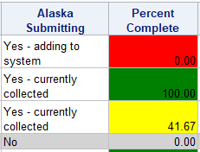

**Step1**: Review the overall completeness

1. Make note if more than 50% of all COVID 19 data elements show zero completeness.
2. If grayed out data elements show red text (as seen below), check the jurisdiction’s implementation spreadsheet here and identify if the jurisdiction intended to send information in those data elements.

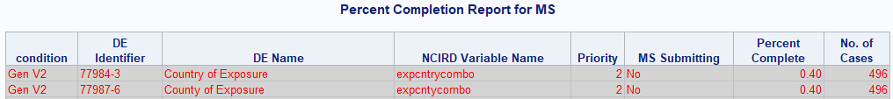

1. A singular period notes that the data element is not in the analysis.



**Step2**: Review priority 1 data elements

1. Filter the priority column to “1”. Make note of COVID 19 priority one data elements that show zero completeness.
2. Review completeness of vaccine repeating group data elements below:

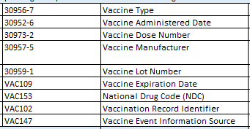



Make note if vaccine **administered type, vaccine manufacturer, vaccine administered date** and **first positive specimen date** show zero completeness.

**Step3**: Using a sample email template found here, draft your findings to the Team for review.